STUDENT ENROLLMENT & COURSE MANAGEMENT SYSTEM (SECMS)

SARATHBABU . J
SHEIK ABDULLAH . M
THIRUMARAN . M
VELMURUGAN . P
VENKATESHWARAN . S

INTRODUCTION

This project aims to centralize all student, course, and enrollment-related data within a single Salesforce application to ensure easy data access, structured workflows, and accurate reporting. The system allows Enrollment Officers to manage student admissions, course registrations, and communication effectively, while instructors and administrators gain full transparency into course allocations and academic progress. The solution also enables automated instructor assignment, task creation, validation checks, and multi-level approval processes for enrollment management.

With Salesforce Flows, Approval Processes, Validation Rules, Reports, and Dashboards, the organization can ensure that all enrollment operations—from admission to course completion—are handled systematically and with continuous monitoring of key performance indicators such as enrollment volume, revenue, student status distribution, and pending approvals.

Project Development Phase:

Project Flow:

Milestone 1: Salesforce Developer Account Creation
Milestone 2: Custom Object Creation (Student, Course, Enrollment, Instructor) Milestone 3: Tabs Creation
Milestone 4: Lightning App Creation Milestone 5: Fields Creation Milestone Milestone 6: Create Relationships
Milestone 7: Page Layout Customization Milestone 8: Milestone 8: Validation Rules
Milestone 9: Flows (Automation) Milestone 10: Approval Process Milestone 11: Reports
Milestone 12: Dashboards Milestone 13: Security Setup Milestone 14: Conclusion

Milestone 2 – Objects:

Activity 1: Creating Student Object:
The purpose of creating the Student custom object is to store and manage information about students such as their personal details, contact information, and enrollment status.
To create the Student object:
Go to the Setup page. Click on Object Manager.
Click on Create → Custom Object.

Enter the details as below:
- Label: Student
- Plural Label: Students
- Object Name: Student
- Record Name: Student Name
- Data Type: Text
- Under Optional Features, select:
- Allow Reports
- Allow Activities (optional but recommended)
- Track Field History (optional, if you want)
- Under Search Status, select:
- Allow Search
- Click Save.

Milestone 4 – Create Relationships:

1. Activity 1: Create Lookup from Enrollment to Student:
Go to Setup → click Object Manager.
- Type Enrollment in Quick Find → click Enrollment c object.
- Click Fields & Relationships → click New.
- Select Lookup Relationship → click Next.
- For Related To, select Student c → click Next.

- Enter Field Label: Student (API Name: Student c).
- Click Next through Field-Level Security and Layout options (ensure it’s visible and added to layout).
- Click Save.

Activity 2: Create Lookup from Enrollment to Course
Purpose:
To link each Enrollment to a Course.

Steps:
- Go to Setup → Object Manager → Enrollment c.
- Click Fields & Relationships → New.
- Select Lookup Relationship → Next.
- Related To: select Course c → click Next.
- Field Label: Course (API Name: Course c).
- Click Next (set visibility and layout) → Save.

Activity 3: Create Lookup from Enrollment to Instructor:
Purpose:
To store which Instructor is assigned to a particular Enrollment.

Steps:
- Go to Setup → Object Manager → Enrollment c.
- Click Fields & Relationships → New.
- Choose Lookup Relationship → Next.
- Related To: select Instructor c → Next.
- Field Label: Instructor (API Name: Instructor c).
- Complete Field-Level Security and Page Layout options → Save

ustomizalions

Milestone 5 – Validation Rules:

Activity 1: Student Email Domain Validation
Purpose:
To ensure students use only allowed institutional email addresses. Steps:
Go to Setup → Object Manager → Student c. Click Validation Rules → New.
Rule Name: Student_Email_Domain_Validation. Error Condition Formula: (example for @student.edu)
- NOT(CONTAINS(Email c, "@student.edu"))

Error Message: Email must be a valid student institutional email. Error Location: Field → Email c.
Click Save.

Activity 2: Fees Must Be Paid Before Approval
Purpose:
Prevent Enrollment from being approved until fees are paid. Steps:
- Go to Setup → Object Manager → Enrollment c.
- Click Validation Rules → New.
- Rule Name: Fees_Must_Be_Paid_Before_Approval.
- Error Condition Formula:
AND(
ISPICKVAL(Enrollment_Status c, "Approved"), Fees_Paid c = FALSE
)
- Error Message: Fees must be paid before approving an enrollment.
- Error Location: Top of Page (or field as needed). Click Save.

Milestone 6 – Approval Process

Activity 1: Create Approval Process for Enrollment Requests
Purpose:
Route Enrollment requests to Training Manager for approval or rejection.
Steps:

- Go to Setup → Approval Processes → select Enrollment c.
- Click Create New Approval Process → Use Standard Setup.
- Process Name: Approval_Enrollment_Request.
- Entry Criteria: Enrollment_Status c = "Requested".
- Save and configure steps.

- Add Approval Step:
- Approver: specific Training Manager user.
- Under Final Approval Actions:
- Add Field Update to set Enrollment_Status c = "Approved".
- Under Final Rejection Actions:
- Add Field Update to set Enrollment_Status c = "Rejected".
- Add Email Alert to send rejection email to student.
- Activate the approval process.

Milestone 7- Tabs

Activity 1: Creating a Tab for the Student Object:
Go to Setup.
- In the Quick Find box, type Tabs.
- Under Custom Object Tabs, click New.
- Select Student from the object list.
- Choose a tab style (icon).
- Click Next, assign it to all profiles, and then click Save.

Activity 2: Creating Remaining Tabs
Now create the Tabs for the remaining Objects, they are “Courses, Instructors, Enrollment”.
Follow the same steps as mentioned in Activity -1

Milestone 8 - The Lightning App

Activity 1: Creating the Lightning Application for the Project
Navigate to Setup.
Enter App Manager in the Quick Find search box. Click New Lightning App.

Provide the app details:
App Name: Student Enrollment & Course Management Developer Name auto-fills
Description: Optional, but can describe the purpose of the app Click Next and choose the following settings:
App Branding (optional): Add logo or select color theme Navigation Style: Choose Standard Navigation
Click Next and assign the app to specific profiles (e.g., Admin, Enrollment Officer, Instructor).
Click Next to select the items (tabs) to be included in the app. Add:
- Student
- Course
- Instructor
- Enrollment
- Reports
- Dashboards
- Home
- Tasks
Click Next and review the app settings. Finally, click Save & Finish.

Milestone 9 – Page Layouts and Record:

Activity 1: Create Record Types for Enrollment:
Purpose:
To separate New Enrollment vs Re-Enrollment processes. Steps:
- Go to Setup → Object Manager → Enrollment c.
- Click Record Types → New.
- For the first record type:
  - Existing Record Type: Master
  - Record Type Label: New Enrollment
  - Enable for required profiles (Admin, Enrollment Officer).
  - Select the default Page Layout → Save & New.
- For the second record type:
  - Record Type Label: Re-Enrollment
  - Enable for same profiles.
  - Select the default Page Layout → Save.

Activity 2: Separate Page Layo Createuts for Each Enrollment Record Type

Purpose:
To show different fields for New Enrollment vs Re-Enrollment. Steps:
- Enrollment c object → click Page Layouts.
- Click New to create a layout for New Enrollment:
  - Clone from existing Enrollment Layout → name it New Enrollment Layout → Save.
  - Keep fields relevant for first-time enrollment: Student, Course, Instructor, Enrollment Date, Status, Fees, etc.
  - Remove unnecessary re-enrollment fields if any.
  - Click Save.
- Again, click New to create Re-Enrollment Layout:
  - Clone existing layout → name it Re-Enrollment Layout → Save.
  - Include fields like previous Enrollment reference (if any), Re-Enrollment Reason, Status, Fees, etc.
  - Click Save.
- Click Page Layout Assignment → Edit Assignment.
- For each profile and record type:
  - New Enrollment → use New Enrollment Layout. 6.Re-Enrollment → use Re-Enrollment Layout.
Click Save.

Activity 3: Enrollment R Addelated Lists to Parent Objects:
Purpose:
To see all Enrollments from Student, Course, and Instructor records.
- Student → Enrollment Related List
Go to Setup → Object Manager → Student c. Click Page Layouts → open the main layout.
In the palette, select Related Lists.
Drag Enrollments related list onto the layout. Customize columns if needed → Save.
- Course → Enrollment Related List
Go to Object Manager → Course c → Page Layouts. Open layout → add Enrollments related list.
Save.
- Instructor → Enrollment Related List
Go to Object Manager → Instructor c → Page Layouts. Open layout → add Enrollments related list.
Save.

Milestone 10 – Automation with Flow

Activity 1: Auto-Populate Enrollment Date (Record-Triggered Flow)
Purpose:
Set Enrollment_Date c to today when Enrollment is created.
Steps:

  - Go to Setup → Flows → New Flow.
  - Select Record-Triggered Flow → Create.
  - Object: Enrollment c.
  - Trigger: A record is created.
  - Optimize for Actions and Related Records → Done.
  - Add Update Records element:
    - Label: Set Enrollment Date.
    - Use record that triggered the flow.
    - Field: Enrollment_Date c → Value: $Flow.CurrentDate.
- Save as SetEnrollmentDate → Activate.

Activity 2: Send Email When Enrollment Approved
Purpose:
When Enrollment_Status c = Approved, send email, alert admin, and set Student to Active.
Steps (high level for document):
  - Create Email Template and Email Alert for student notification.
  - Go to Flows → New → Record-Triggered Flow.
  - Object: Enrollment c, Trigger on update.
  - Condition: Enrollment_Status c Equals "Approved".
  - Add Get Records to fetch related Student c.
  - Add Action (Email Alert) to send email to student.
  - Add Action to notify Admin if needed.
  - Add Update Records to set Student c.Status c = "Active".
  - Save as Enrollment Approved Action → Activate.

Activity 3: Auto-Assign Instructor Based on Course Category
Instructor C

Steps:
- Prepare Instructor c records with codes (e.g., INSTR_A, INSTR_B, INSTR_C).
- Create Record-Triggered Flow on Enrollment c (created/updated).
- Add Get Records to fetch related Course c.
- Add Decision element on Course r.Category c:
- Technical / Language / Non-Technical outcomes.
- For each outcome:
- Get Instructor record (A/B/C) based on code or name.
- Update Records: set Instructor c = Get_Instructor_X.Id.
- Save as AutoAssign_Instructor → Activate.

Activity 4: Auto-Create Task for Follow-Up
Purpose:
When Enrollment is “Requested”, create a follow-up task for Admin.
Steps:
- Create Record-Triggered Flow on Enrollment c.
- Trigger: Record created or updated; condition Enrollment_Status c
= "Requested".
- Add Get Records to fetch Admin user (by Username / Profile).
- Add Formula (Date): TODAY() + 2 for due date.
- Add Create Records for Task:
- Subject: Follow up on enrollment request.
- OwnerId: Admin user Id.
- WhatId: Enrollment Id.
- ActivityDate: formula Today + 2.
- Save as Create_Followup_Task → Activate.

Milestone 11 – Reports:

Activity 1: Create “Students by Status” Report

- Go to Reports → New Report.
- Report Type: Students.
- Group rows by Status c.
- Add columns as needed (Name, Email, Phone).
- Save as Students by Status.

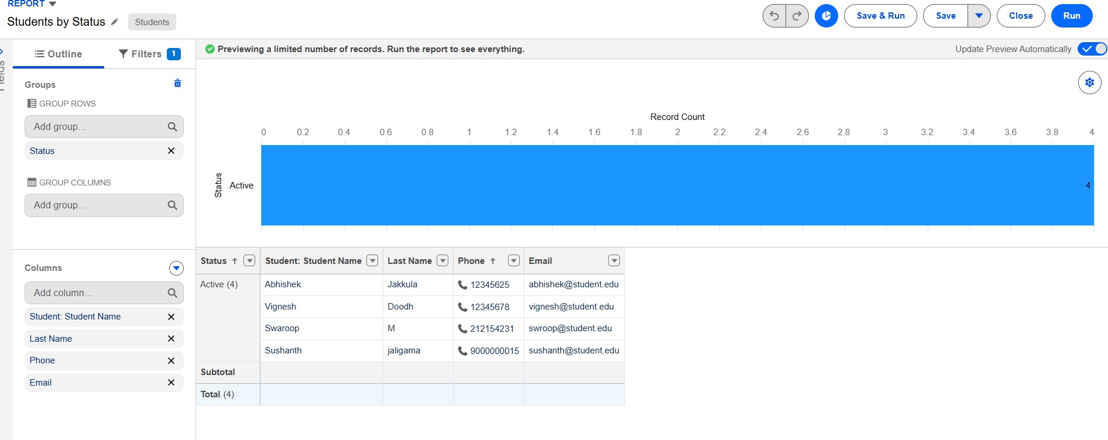

Activity 2: Create “Enrollments by Course” Report

- New Report → Report Type: Enrollments. 2.Grouprows by Course r.Name.
- Show Record Count per course.
- Save as Enrollments by Course
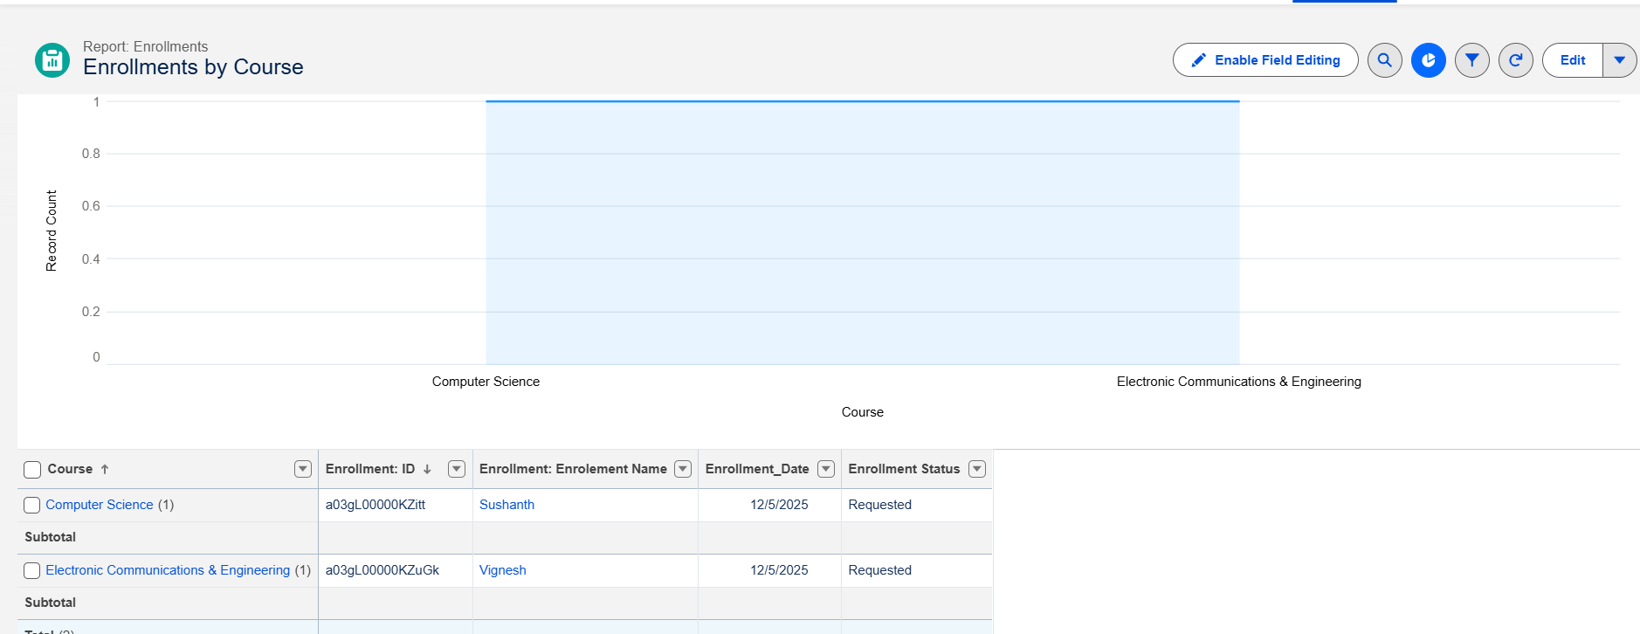

Activity 3: Create “Pending Enrollment Approvals” Report

  - New Report → Enrollments report type.
  - Filter: Enrollment_Status c = "Requested".
  - Add columns (Student, Course, Owner, Created Date).
  - Save as Pending Enrollment Approvals.

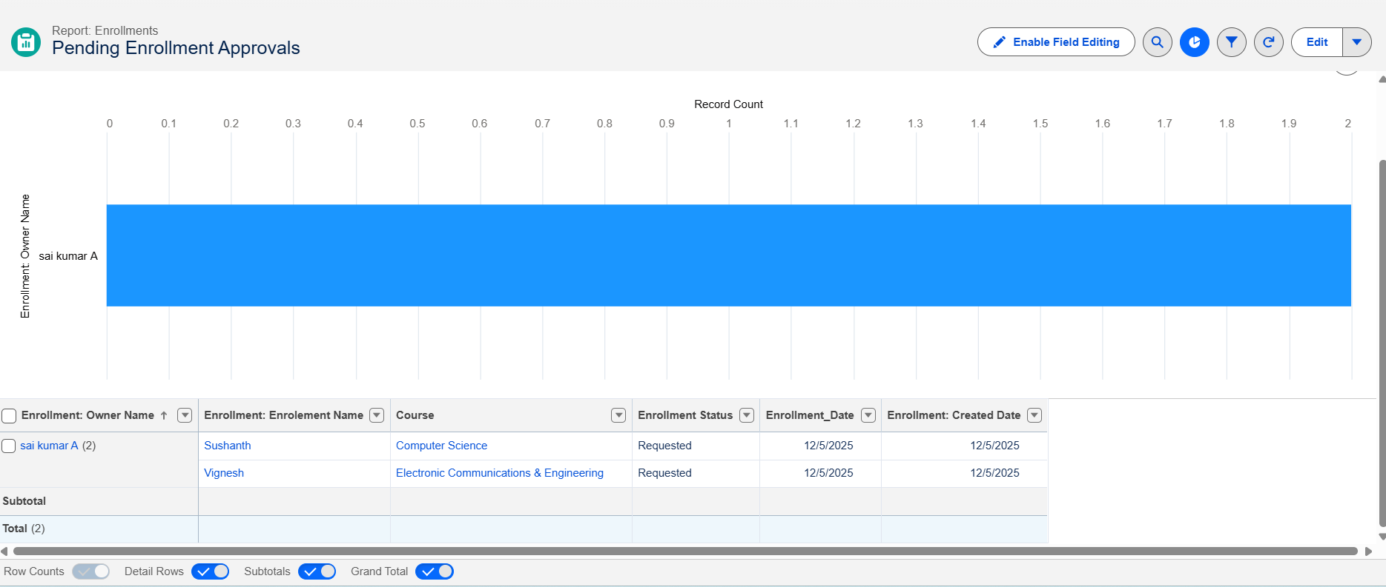

Activity 4: Create “Revenue Report (Fees Paid)” Report

- New Report → Enrollments report type.
- Filter: Fees_Paid c = TRUE.
- Group by Course r.Name.
- Summarize Course_Fee c or similar fee field.
- Save as Revenue Report – Fees Paid.

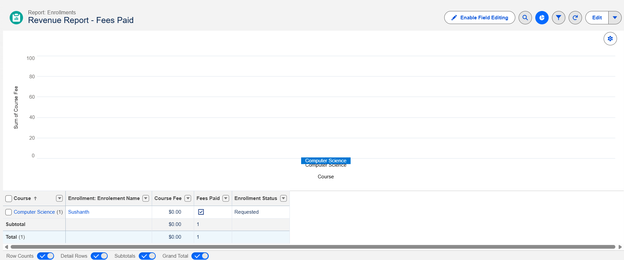

Milestone 12 – Dashboards:

Activity 1: Create “Student Managemet Dnashboard”

Steps:

- Go to Dashboards → New Dashboard.
- Name: Student Management Dashboard.
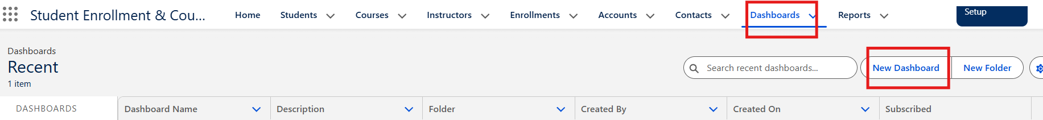

- Select folder → Create.
- Select new Dashboard folder and Save.

Add components:

  - Donut Chart → using Students by Status report.
  - Bar Chart → using Enrollments by Course report.

- Gauge → | using Revenue | Report – Fees Paid (sum of
revenue  - Table → | field).  using Pending | Enrollment Approvals report.

4. Arrange components on canvas.
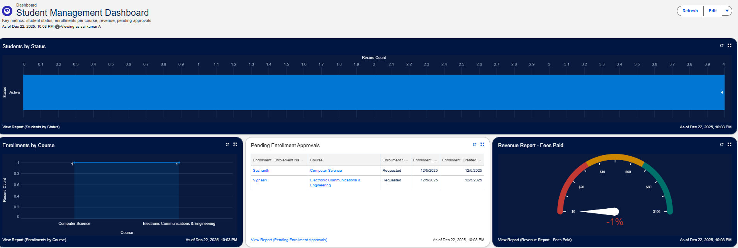

Click Save → Done.

Milestone 13 – Security Setup

Activity 1: Configure Profiles

):Go to Setup → Profiles → New (or CloneProfiles Required:
  - Admin – Full access.
  - Enrollment Officer – Create/Update Enrollments.
  - Instructor – Read-only access to assigned Enrollments.
- Steps (example for Enrollment Officer fName: Enrollment Officer.
- In Object Settings:
- Enrollment c: Read, Create, Edit.
- Student c / Course c: Read (and Edit if required).
- Save.

Repeat similarly for Instructor profile with Read-Only
on Enrollments

Activity 2: Create Permission Sets

- Go to Setup → Permission Sets → New.
- Create Custom Object Access (additional access to project objects if needed).
- Create Dashboard Editor (Create/Customize Reports & Dashboards permissions).
- Assign to relevant users.

Activity 3: Configure Sharing & OWD

Steps:

- Go to Setup → Sharing Settings.

Set Organization-Wide Defaults:
  - Students (Student__c): Public Read/Write.
  - Courses (Course__c): Public Read/Write.
  - Enrollments (Enrollment__c): Private.
- Save.

For Instructor access to assigned Enrollments, optionally:
- Add a User lookup on Enrollment (Instructor User).

- Use a simple Record-Triggered Flow to set OwnerId = Instructor User so they can see only their own records.

Output

FUNCTIONAL & PERFORMANCE TESTING

During the testing phase, screenshots were captured from the Salesforce user interface to verify the proper functioning of all implemented features of the Student Enrollment & Course Management System (SECMS). These include student, course, instructor, and enrollment record creation; validation rule checks for mandatory fields, eligibility, and enrollment constraints; verification of record type behavior for different course categories; flow execution for automated enrollment approvals and seat availability checks; and Apex trigger functionality to ensure automatic confirmation and record updates. Additionally, screenshots of generated reports and dashboards were documented to validate accurate data visualization, enrollment tracking, and performance monitoring. Submit the Screenshots while testing.

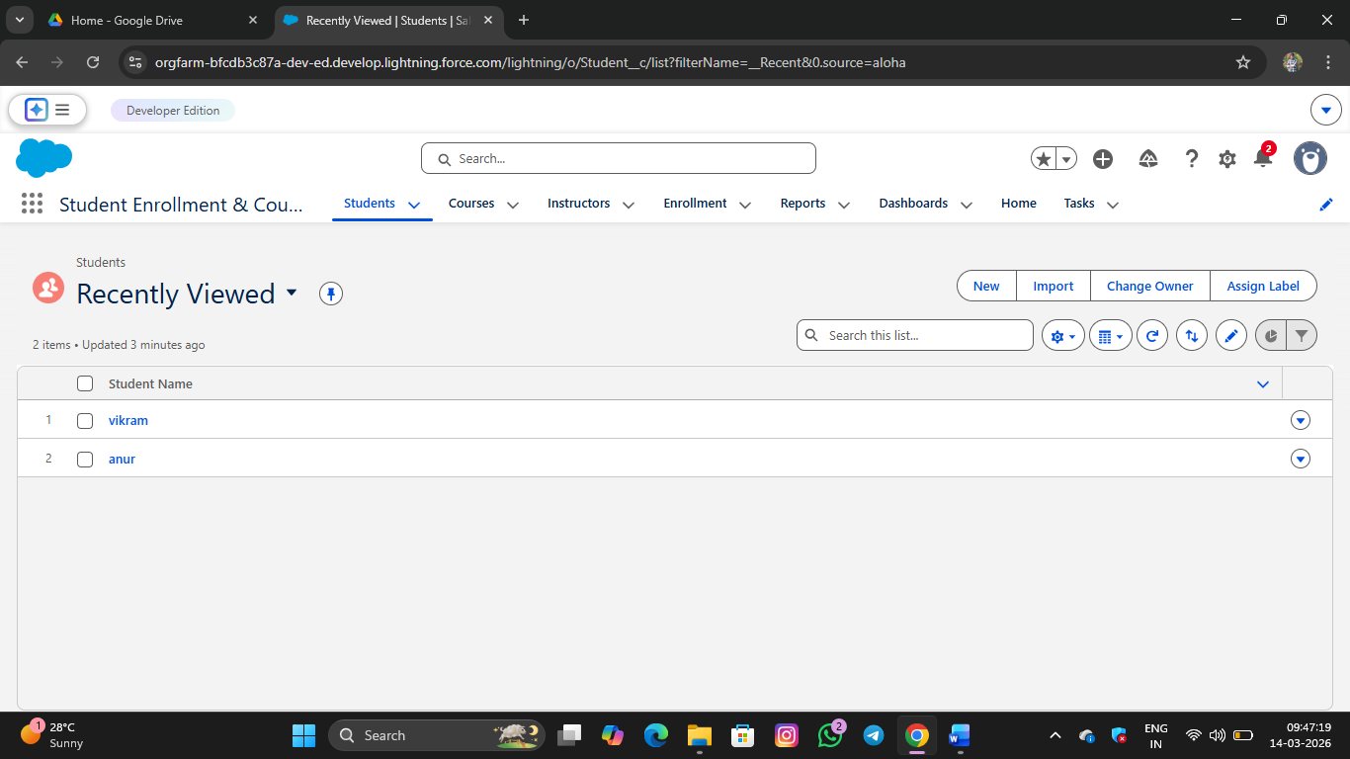

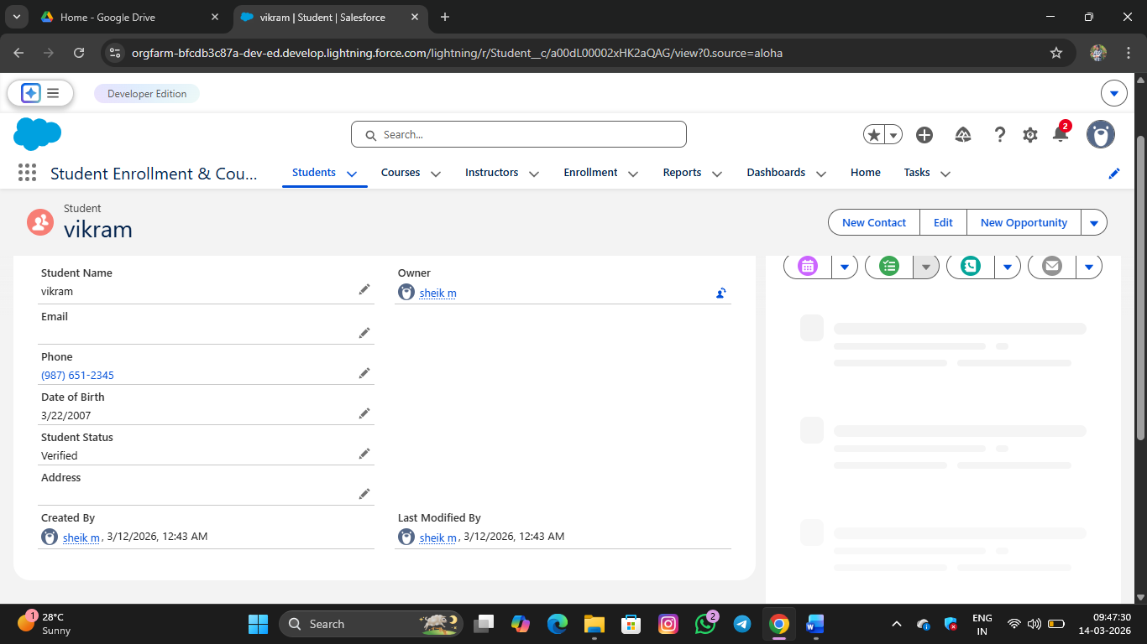

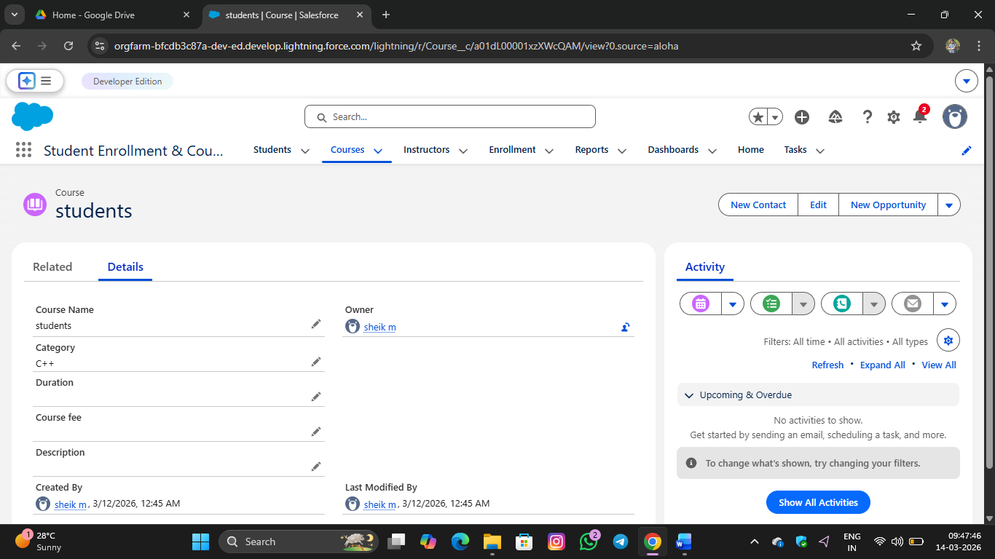

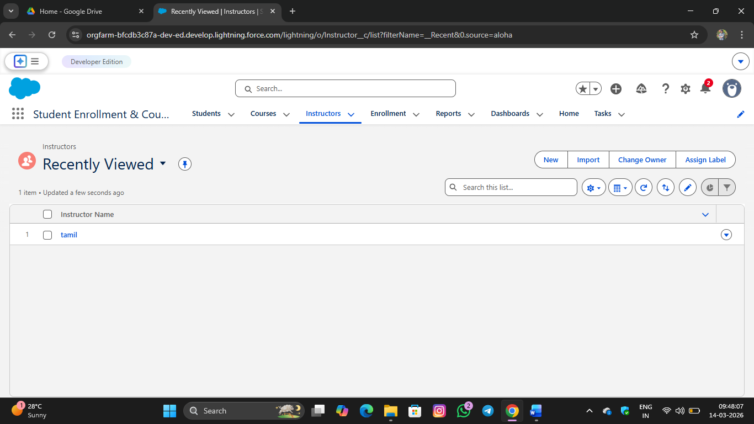

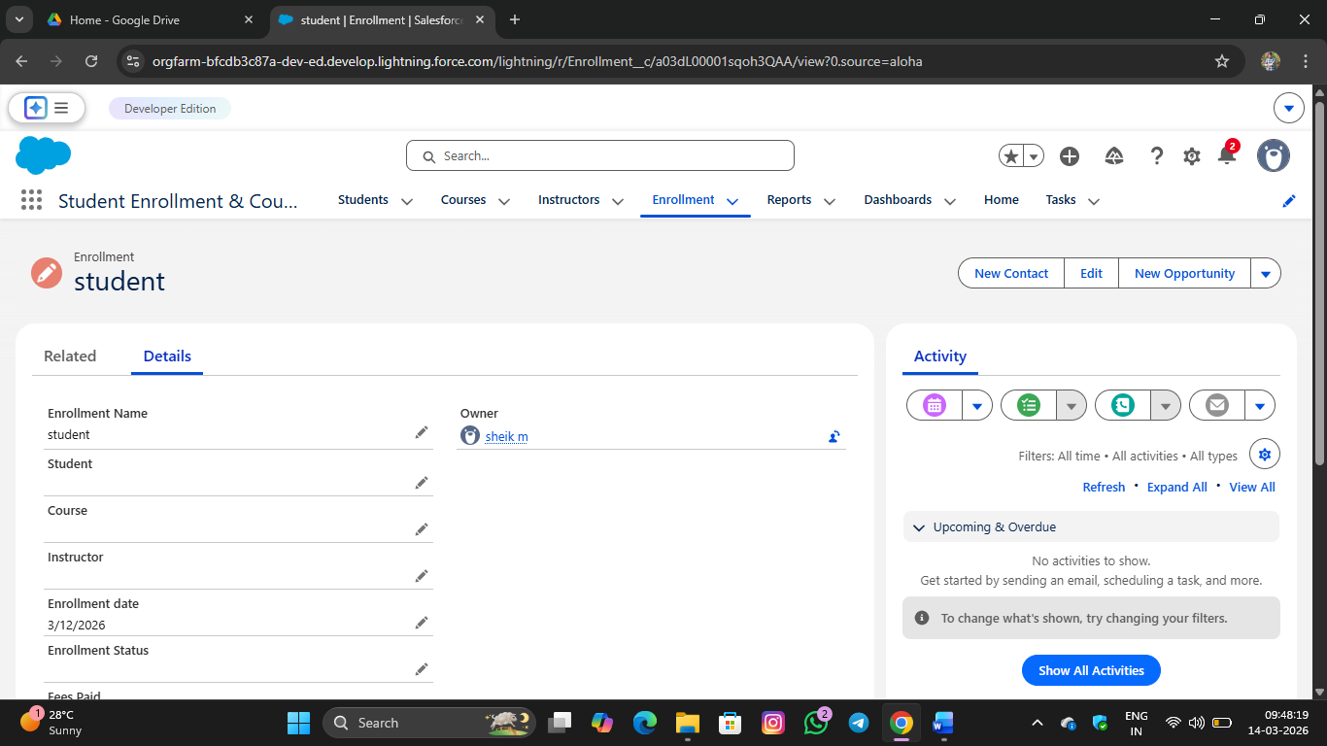

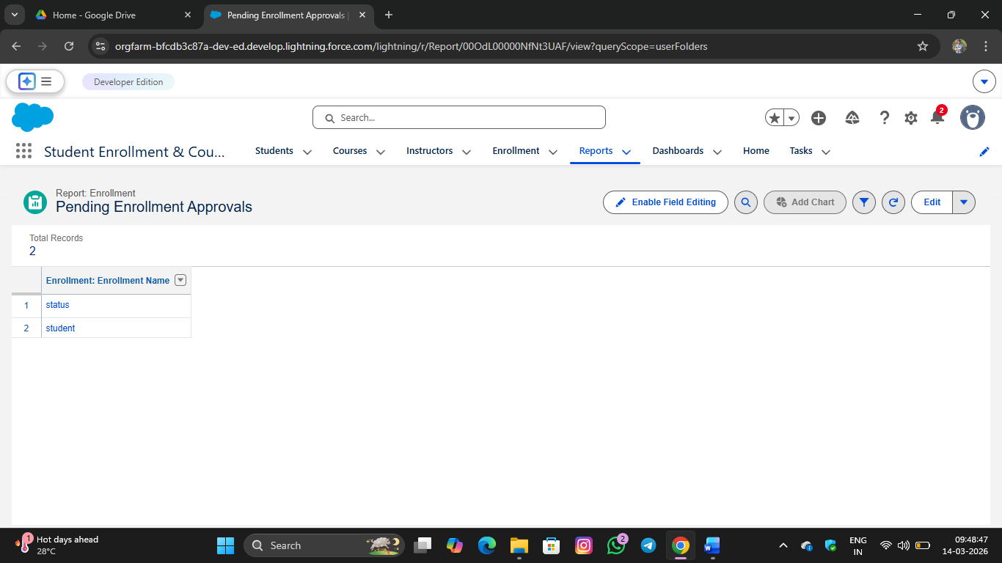

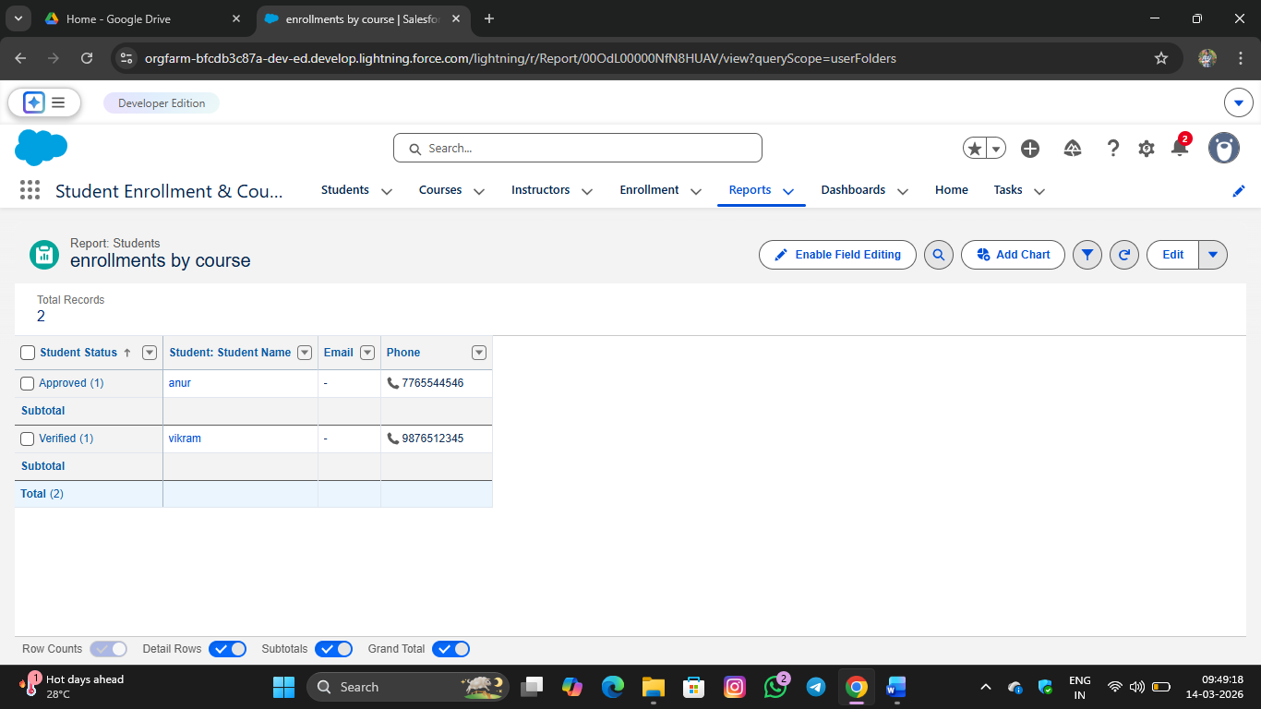

ADVANTAGES & DISADVANTAGES

Advantages

  - Centralized data
  - Automated workflows
  - Real-time reporting

Disadvantages

  - Salesforce dependency
  - Requires initial configuration effort

- Conclusion:

The Salesforce Student Enrollment & Course Management System successfully streamlines the entire student academic lifecycle—from student registration and course creation to enrollment management, instructor assignment, approvals, revenue tracking, and reporting. By leveraging Salesforce’s automation tools such as validation rules, flows, approval processes, and dashboards, the system improves data accuracy, operational efficiency, and decision-making. This project demonstrates how Salesforce can transform manual academic processes into a scalable, reliable, and user-friendly digital solution.

FUTURE SCOPE
  - Payment gateway integration
  - Student self-service portal
  - Analytics-driven insights

  - Mobile access support

APPENDIX
  - Source Code: Salesforce Configuration
  - Dataset: Salesforce Objects
  - GitHub / Demo: Salesforce Developer Org

Thank You

